ELEKTRONİK MALZEME VE FİYAT LİSTESİ

1-)PİXHAWK ORANGE CUBE

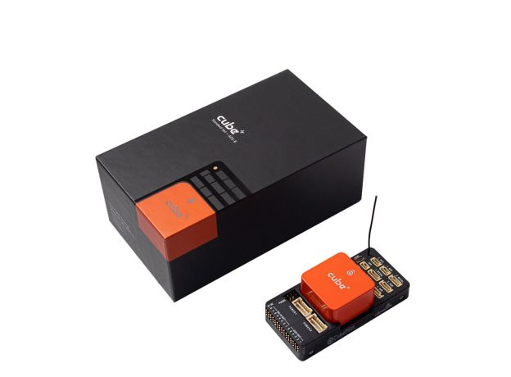

https://www.drone.net.tr/drone-yedek-parcalari/pixhawk-the-cube-orange-imu-v8-standard-set-otopilot-sistemi-ads-b-carrier-board.html?sl=en

FİYAT:14.999TL

2-) RASPERRY Pİ

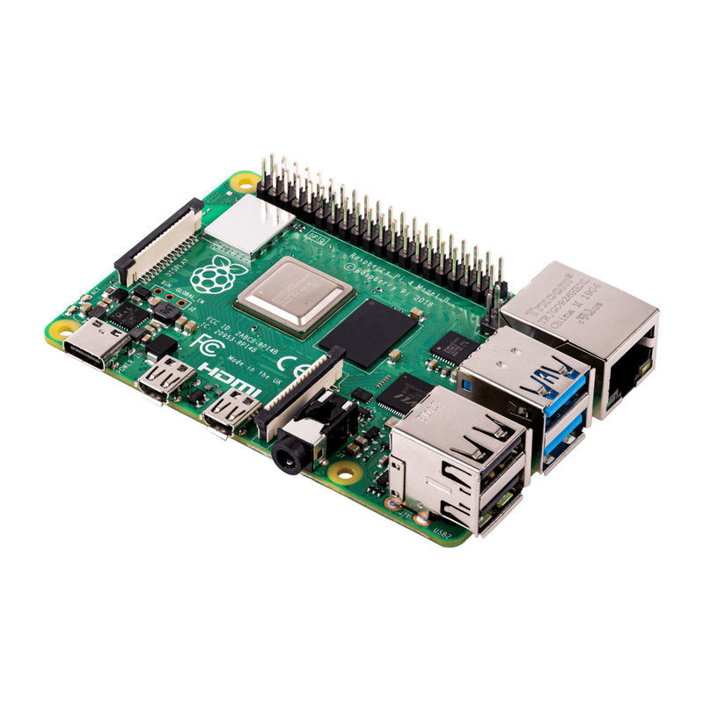

<https://www.direnc.net/raspberry-pi-4-4gb-model-b-rev12?language=tr&h=6c5243f5&gclid=Cj0KCQjwpcoBhCGARIsAH6ote8FoyA4S39B3KXJHoQcogtbwtvMPg9ybtFMhdVoxzzTv0PtRWoVstUaAnaUEALw_wcB>

FİYAT:2.519TL

3-JATSON NANO

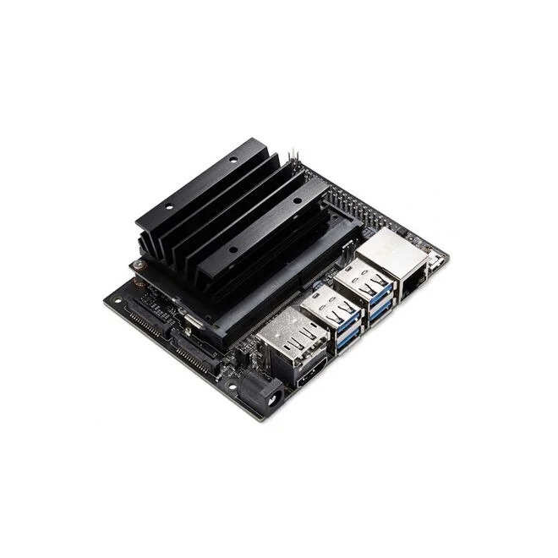

<https://www.robotistan.com/nvidia-jetson-nano-developer-kit-b01?language=tr&h=e398b31b&gclid=Cj0KCQjwpc-oBhCGARIsAH6ote-v-woeT9Hj7S7KHIQdkSVM0vt_gopwN3tcd7rX_c6ZsGzG9evu3ywaAhKrEALw_wcB>

FİYAT:7.060TL

4-)FIRÇASIZ MOTOR

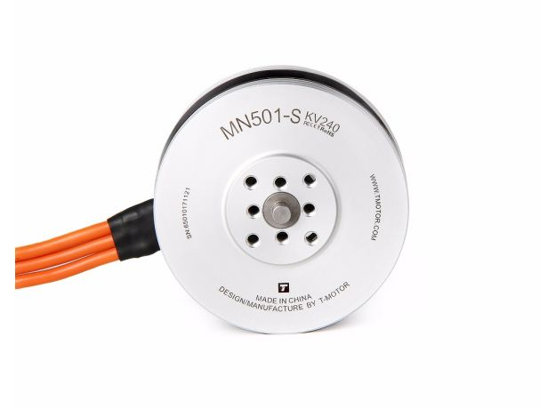

<https://www.drone.net.tr/drone-motorlari/t-motor-mn501-s-kv240-fircasiz-motor.html>

FİYAT:4x2800=11.200TL

5-) 40A ESC (ESC tasarımını yerli olarak programlanabilir bir ESC olarak üretmeyi planlıyoruz, buraya alternatif olarak koyuyoruz. Tasarladığımız ESC yi ayrıca rapor olarak hazırlayacağız.)

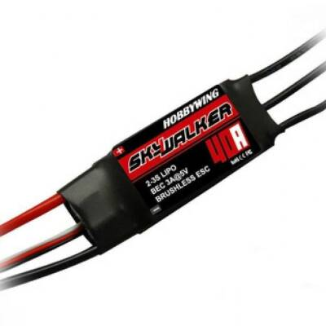

<https://www.motorobit.com/skywalker-esc-40a-brushless-fircasiz-motor-hiz-kon?gad=1&gclid=Cj0KCQjwpc-oBhCGARIsAH6ote8vV_mjzW9xTsIW90cjYPAVue_YNf-EddiemaooNws0ODid7Yh_O7EaAskBEALw_wcB>

FİYAT:4x438=1.752TL

6-)GÜÇ DAĞITIM KARTI (Güç dağıtım kartını kendimizi tasarlamayı planlıyoruz, buraya alternatif olarak koyuyoruz. Ayrıca Güç dağıtım kartı tasarımını ayrı bir rapor hazırlayacağız.)

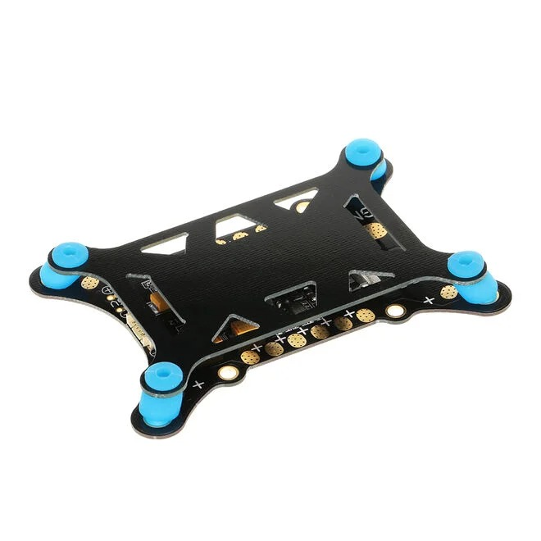

<https://www.robotistan.com/guc-dagitim-karti-5in1-5-12-v-bec-darbe-emici-platformlu-apm-pixhawk?language=tr&h=5f39e2a0>

FİYAT:951TL

7-)15\*5.5 KARBON FİBER PERVANE

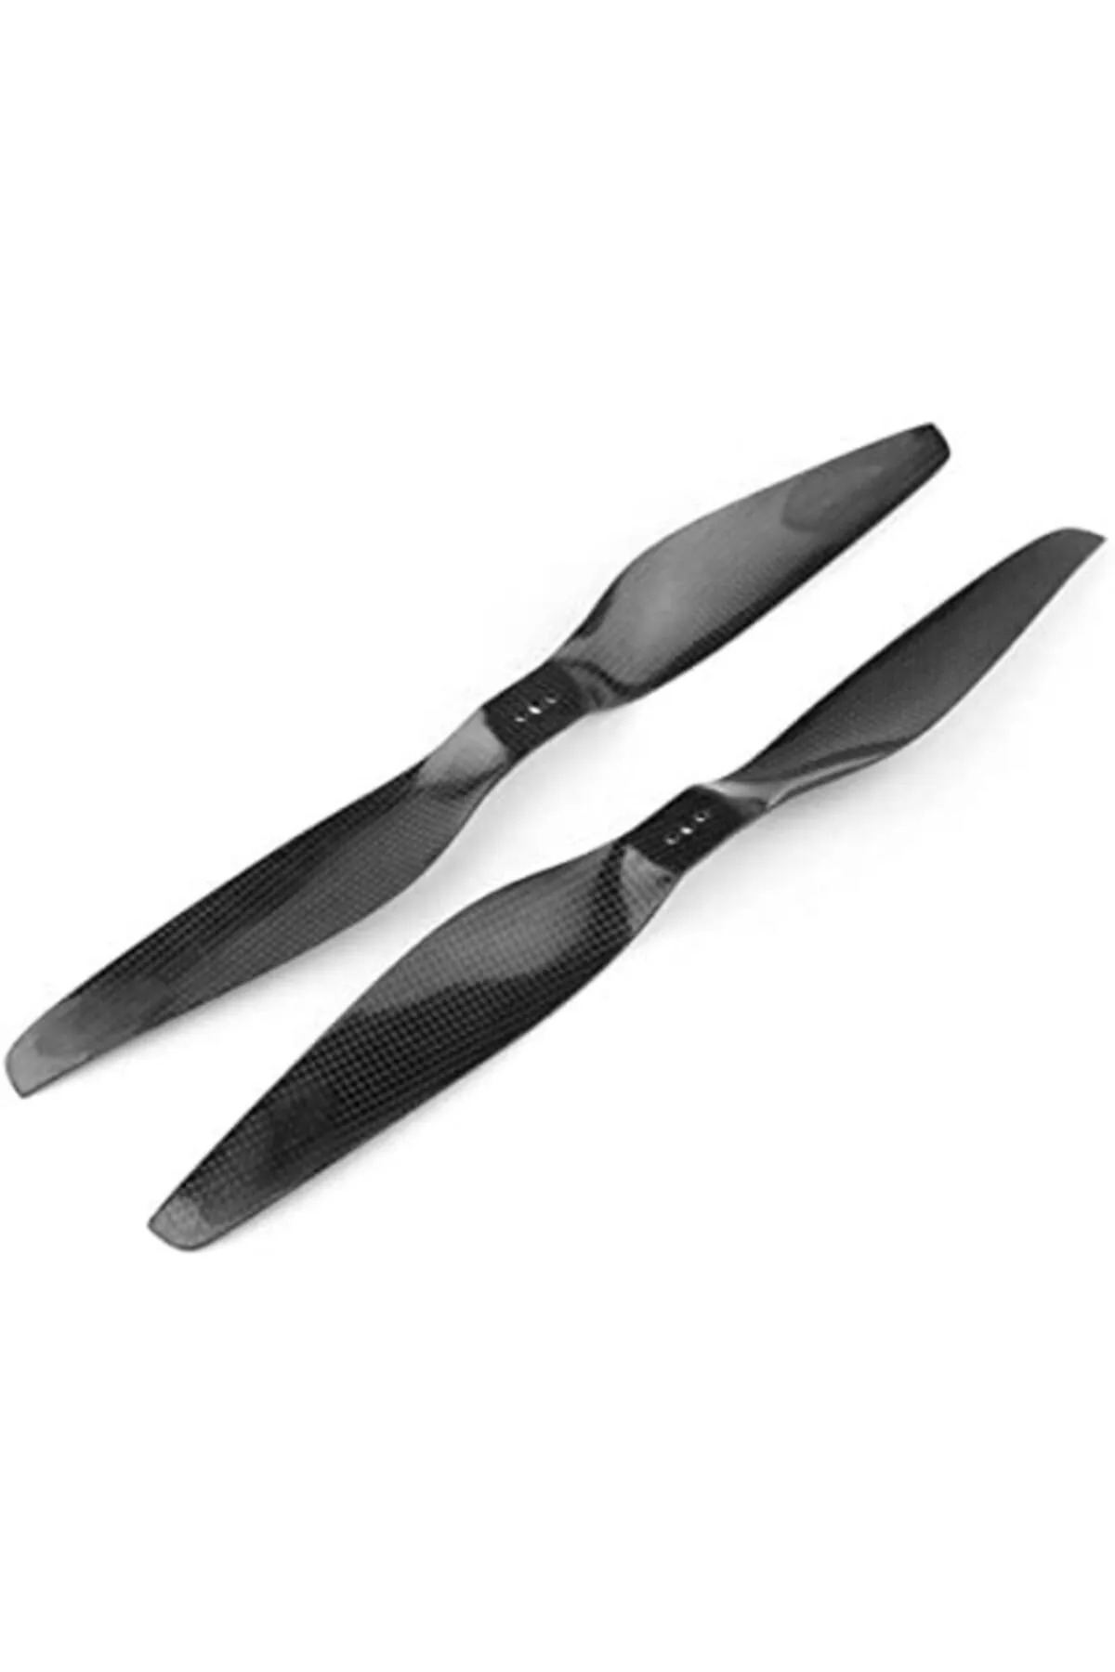

<https://www.dronmarket.com/urun/t-motor-1555-cw-ccw-dron-pervanesi>

FİYAT=2x240=480TL

8-)10000mAH Li-Po Pil

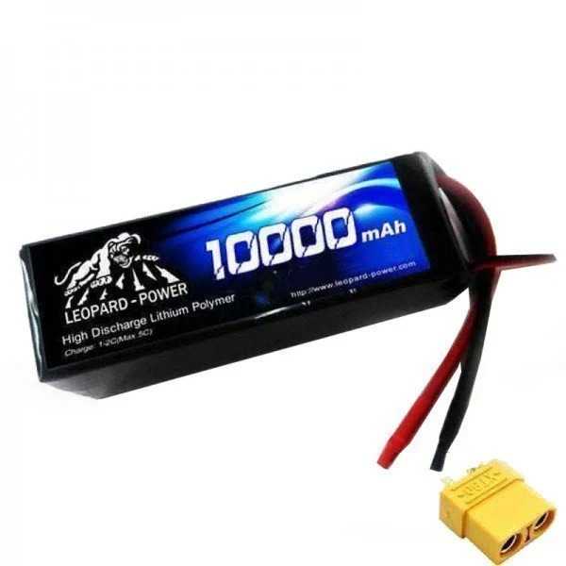

<https://www.f1depo.com/urun/6s-10000mah-40c-lipo-batarya-22-2v-pil>

FİYAT:5.000TL

9-)PİXHAWK HERE 3 CAN GPS

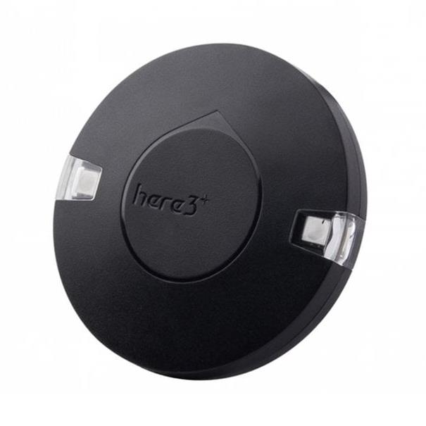

<https://www.oyuncakhobi.com/pixhawk-here-3-can-gps-/-gnss-with-m8p>

FİYAT:10.000TL

10-MİNİ SU POMPASI

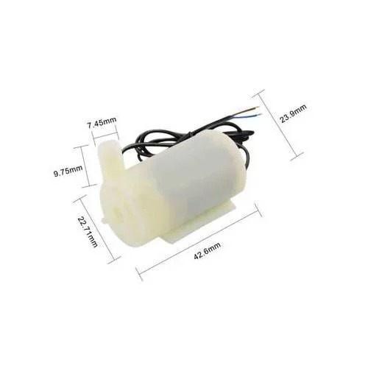

<https://www.robotistan.com/mini-dalgic-pompa-6v-120-litresaat?language=tr&h=f530a050&gclid=Cj0KCQjwpc-oBhCGARIsAH6ote-gmLit9fRcm4r7WonMr_6T76_V_-ZhdFd54fgsFHi_DDTE4mzebdAaAsGLEALw_wcB>

FİYAT:30TL

11-)LEHİM

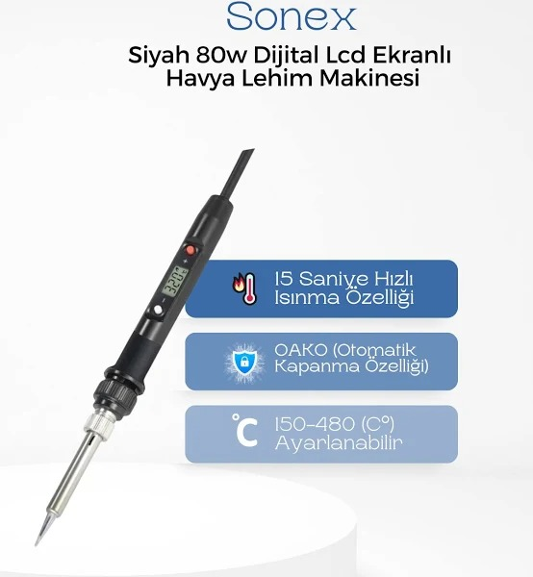

<https://www.trendyol.com/sonex/siyah-80w-dijital-lcd-ekranli-havya-lehim-makinesi-p-308653229?boutiqueId=61&merchantId=143692&storefrontId=1&countryCode=TR&language=tr&gads=true&srsltid=AfmBOopvbE4ueSJl7hpAe6X539NctZ0VbTGAiqoCKn6qthj0bbEoJ8cJLVo>

FİYAT:230TL

12-LEHİİM TELİ

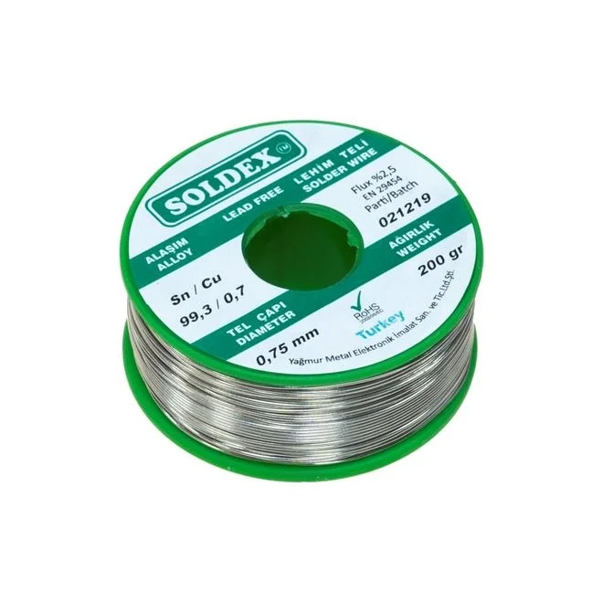

<https://www.robotistan.com/soldex-075-mm-200-gr-kursunsuz-lehim-teli-993-sn-07-cu?language=tr&h=d69646f4&gclid=Cj0KCQjwpc-oBhCGARIsAH6ote93DGv8zLS7lHjER6uxgZmO46_UU9w5tEHH6JtURc0HEhHsC-mtV10aAjnsEALw_wcB>

FİYAT:400TL

13-)XT90

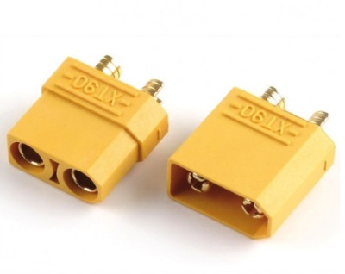

<https://www.robitshop.com/urun/xt-90-batarya-konnektor-disi-erkek-cift?gclid=Cj0KCQjwpc-oBhCGARIsAH6ote8I64SC8MoKQLG5aH-yYHAFXxVGDiHTDJ9i9bTqgCdGPcUUc87GnCcaAvK6EALw_wcB>

FİYAT:30x4=120TL

14-150A BIÇAK SİGORTA

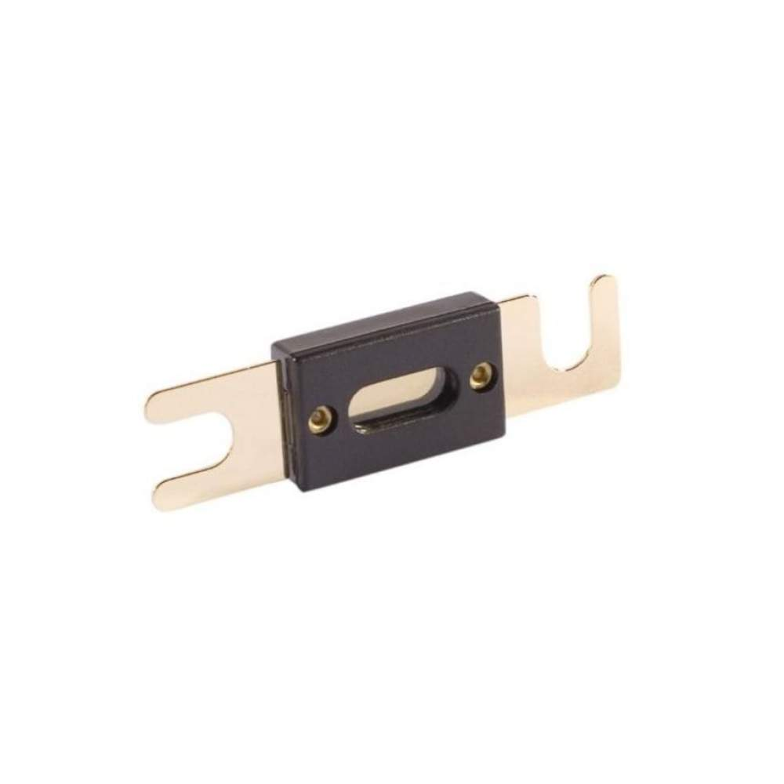

<https://enerjiburada.com/bicak-sigorta-buyuk-boy-siyah-150-amper-2120868?seller_id=2022&language=tr&currency=TRY&gclid=Cj0KCQjwpc-oBhCGARIsAH6ote97kk28n1mKuhOjImkPizEbwgnhczaG_lUIqwZm5cb3EIa13KZIGjsaAlEYEALw_wcB>

FİYAT:2x80=160TL

15-)AKIM KESİCİ

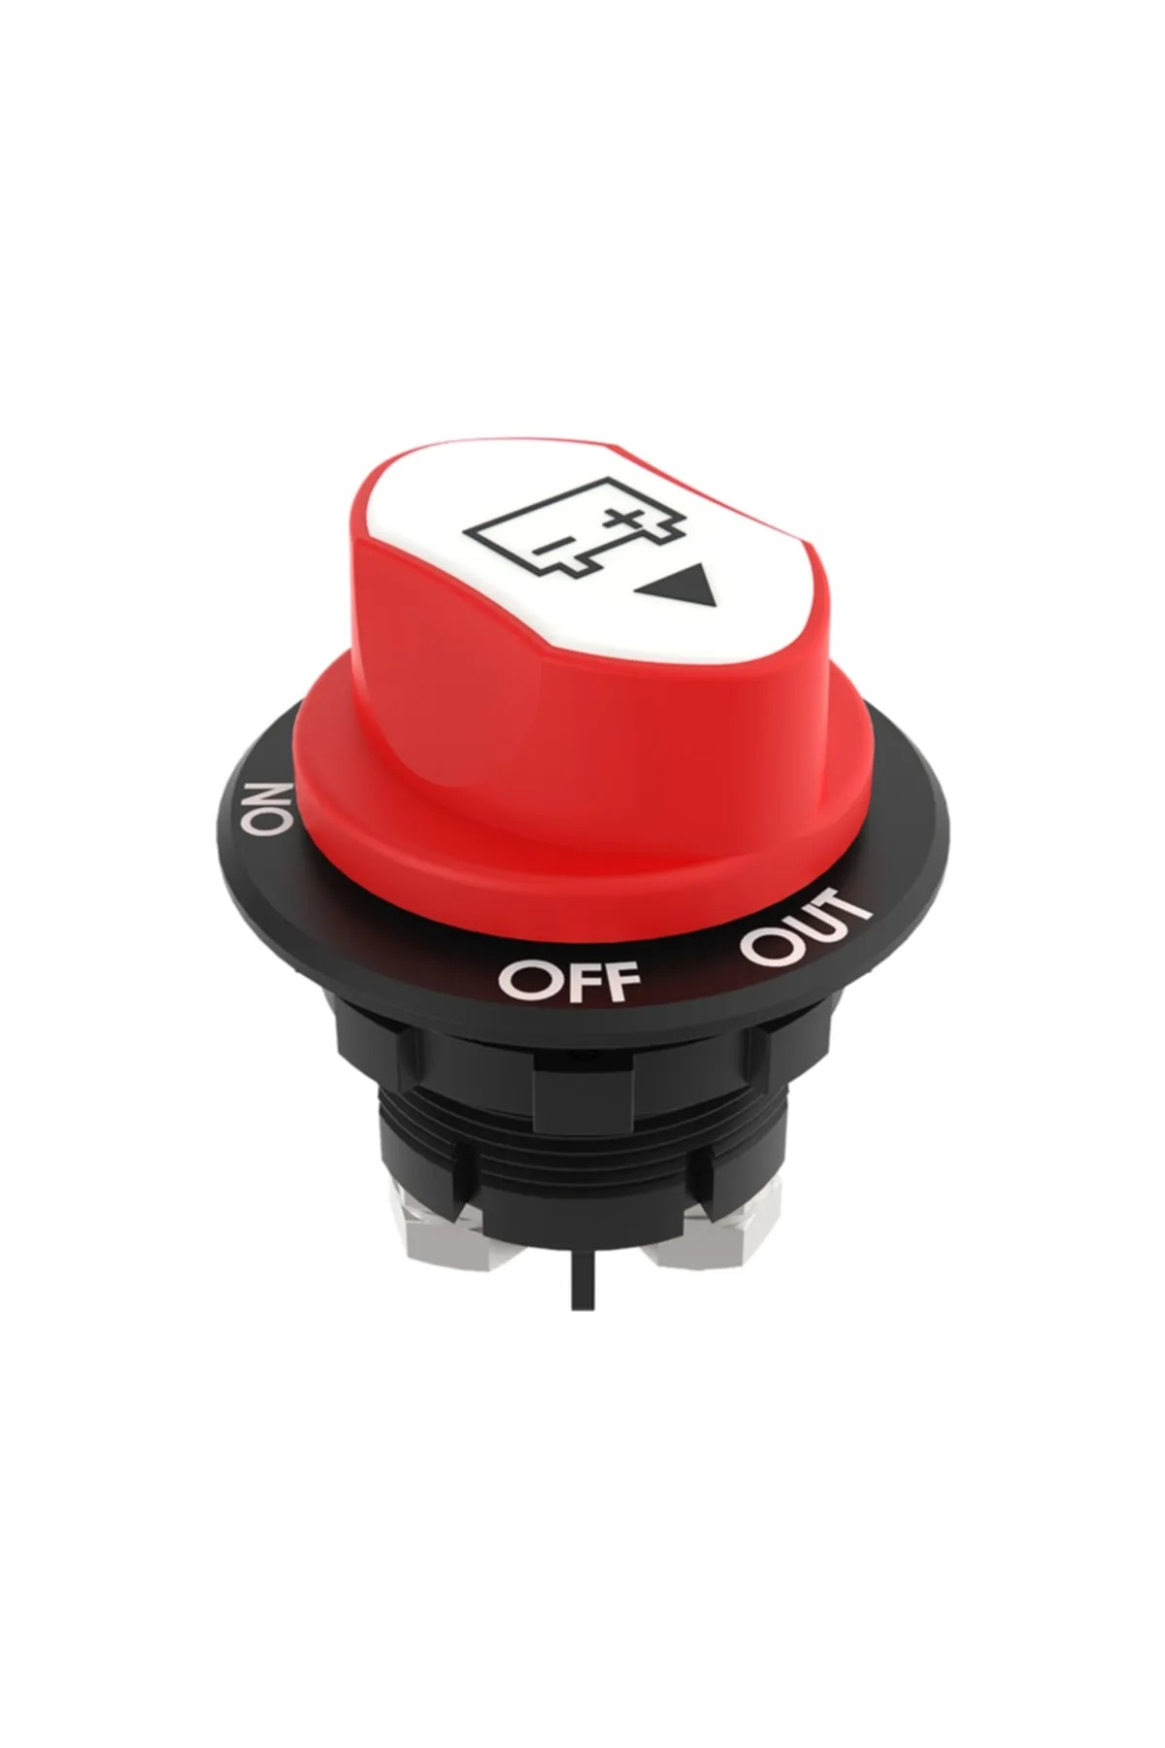

<https://www.trendyol.com/allestock/mini-aku-devre-kesici-salter-ip56-12-24v-100a-p-252774500?boutiqueId=61&merchantId=451131&storefrontId=1&countryCode=TR&language=tr&gads=true&tyutm_source=google&tyutm_medium=cpc&tyutm_campaign=x:home_y:gm_z:gm_t:pla_standard_shopping&gclid=Cj0KCQjwpc-oBhCGARIsAH6ote-L_PY8i4MRumDUrIHGXXA_YhefqLpZF6C_t2GDt6BjhLTQ-nvDHRUaAmchEALw_wcB>

FİYAT:200TL

16-)MAKARON SETİ

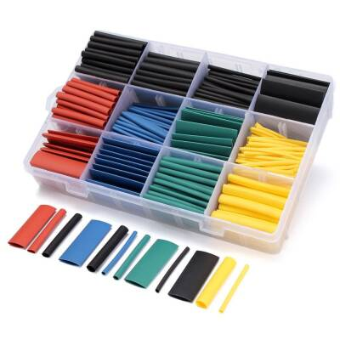

<https://www.motorobit.com/makaron-seti-530-adet?gad=1&gclid=Cj0KCQjwpc-oBhCGARIsAH6ote-2YuKQCJUDtkY908pdWmx40uHZMl0z9yUL92tixTrb2OpaUJU4tY0aAhb0EALw_wcB>

FİYAT:100TL

17-)1 METRE KIRMIZI AWG KABLO

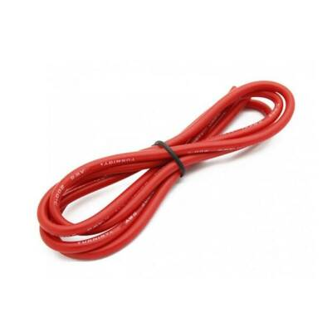

<https://www.motorobit.com/22-awg-silikon-kablo-kirmizi-1-metre?gad=1&gclid=Cj0KCQjwpc-oBhCGARIsAH6ote9-F_qqfo2wBRD1bbA17t_fKVYeHykz9-ygFTb3ttX_8OIDSIGYf4AaAkpuEALw_wcB>

FİYAT=2x10=20TL

18-1 METRE SİYAH AWG KABLO

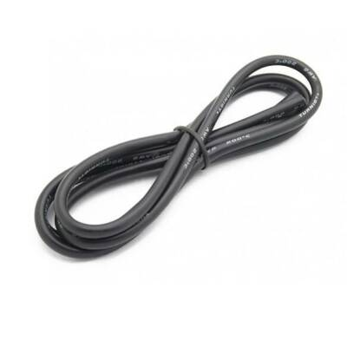

<https://www.motorobit.com/20-awg-silikon-kablo-siyah-1-metre?gad=1&gclid=Cj0KCQjwpc-oBhCGARIsAH6ote9BqimL3LuvL2TyIJRL2SsplxOGcZXvFFwIdyhv1M0DcsiDDhu14M4aAmZ4EALw_wcB>

FİYAT:2x13:26TL